MADISON GREEN MASTER ASSOCIATION
CLUBHOUSE ACTIVITY CALENDAR
OCTOBER 2021

MGMA CLUBHOUSE ACTIVITY CALENDAR

Clubhouse Hours of Operation

Monday–Thursday
7:00 am–9:00 pm

Friday,
Saturday & Sunday
7:00 am – 8:00pm

Pool Hours
Dawn – Dusk

Sunday | Monday | Tuesday | Wednesday | Thursday | Friday | Saturday
 |  |  |  |  | 1 | 2
3 | 4 | 5  ARC Meeting  12:00 pm  Budget Meeting 6pm | 6 | 7 | 8 | 9
10 | 11  Oakmont BOD Mtg  6:30 pm | 12 | 13  Budget Meeting 6pm | 14  Lexington BOD Mtg  7 pm | 15 | 16
17 | 18 | 19  ARC Meeting  12:00 pm  Budget Meeting 6pm  Wyndham BOD Mtg  7 pm  Fairfax BOD Mtg  7 pm | 20 | 21 | 22 | 23
24  31 HALLOWEEN | 25  Walden BOD Mtg  7 pm | 26  Saybrook BOD Mtg 7:00pm | 27  MGMA BOD Mtg  6:30 pm | 28 | 29 | 30

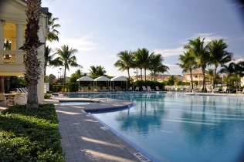

MGMA 2003 Crestwood Boulevard North, Royal Palm Beach, Florida 33411
Phone 561-793-1715 Email:madisongreeninfo@madisongreen.net
Website:www.madisongreen.net

